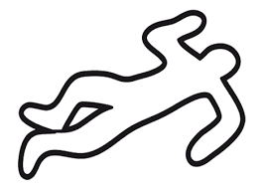

CRIME SCENE
Kitchen Hygiene
Think of things that could be a Hazard (danger) in the food room. Write down the hazard and how you could prevent (stop) it from happening.
You should include;
Personal hygiene, food safety, food contamination and food poisoning concerns.
Hazards | Prevention
Spilling food | Clean all spills immediately

